**Lab - 01**

**Title:** Hub Connection Between Two PC

**Objective:**

To establish a basic network connection between two PCs using a hub and test connectivity by pinging between the devices.

**Equipment:**

* CISCO Packet Tracer software
* 2 PCs (PC1 and PC2)
* 1 Hub (4-port or 8-port)
* 2 Straight-through Ethernet cables

**Theory:**

In a hub-based network, multiple devices are connected to a hub, which broadcasts any incoming data to all connected devices. A hub operates at Layer 1 of the OSI model (Physical Layer) and does not filter or direct traffic based on MAC addresses like switches do. Hubs are simple network devices that can only extend the communication range between devices but do not manage traffic efficiently.

When two PCs are connected to a hub and assigned unique IP addresses within the same subnet, they can communicate with each other via a process called pinging.

The ping command sends ICMP (Internet Control Message Protocol) packets to the destination device, and if the devices are properly connected, the destination will send a reply. This allows us to verify network connectivity.

**Results:**

When the ping command is executed from PC1 to PC2, the following observations were made:

* In **Real-Time Mode**, the ping requests from PC1 to PC2 were successful, confirming that the two PCs are properly connected via the hub.
* In **Simulation Mode**, the packet flow showed the ICMP request and reply being sent and received through the hub, which broadcasts data to both PCs.

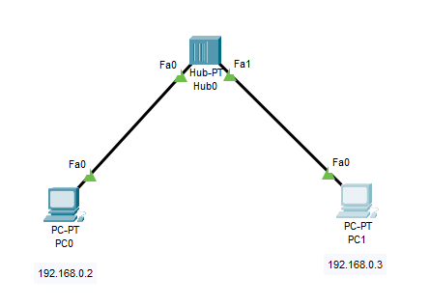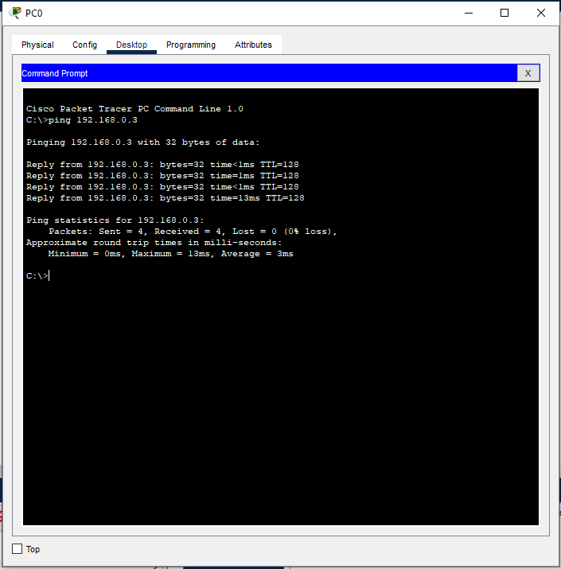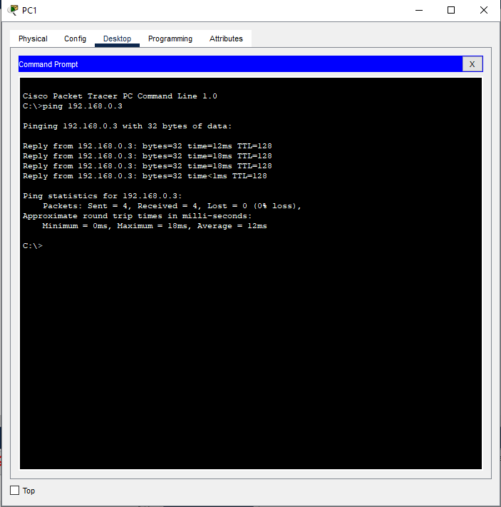

**Conclusion:**

In this lab, we successfully connected two PCs through a hub and verified network connectivity using the ping command. The use of a hub allows the connected devices to communicate, but the hub broadcasts all incoming traffic to every port, which may lead to network inefficiencies in larger setups. This lab demonstrated basic networking concepts and reinforced the functionality of a hub as a simple, non-intelligent device operating at the Physical Layer of the OSI model.

**Lab – 02**

**Title:** Switch Connection Between Two PCs

**Objective:**

To establish a network connection between two PCs using a switch and verify their connectivity by pinging between the devices.

**Equipment:**

CISCO Packet Tracer software

2 PCs (PC1 and PC2)

1 Switch (8-port or 24-port)

2 Straight-through Ethernet cables

**Theory:**

A switch is a network device that operates at Layer 2 of the OSI model (Data Link Layer). Unlike a hub, which broadcasts all incoming data to every connected device, a switch is more intelligent. It forwards data only to the specific destination device by learning and storing the MAC addresses of connected devices in its MAC address table. This reduces network congestion and improves communication efficiency. In this lab, two PCs will be connected to a switch. Both PCs will be assigned unique IP addresses within the same subnet, and we will test the connection between them using the ping command. If the network is set up correctly, the ping command will successfully send ICMP packets from one PC to another and receive replies.

**Results:**

* In **Real-Time Mode**: The ping command executed from PC1 to PC2 was successful, confirming the two PCs are properly connected through the switch. Similarly, the ping from PC2 to PC1 was also successful. This indicates a fully functional connection between the devices.
* In **Simulation Mode**: The simulation showed that the switch learns and stores the MAC addresses of the connected devices after receiving the initial packet. Future 2 packets are then forwarded directly to the intended recipient rather than being broadcast to all ports, demonstrating the switch’s efficient handling of network traffic.

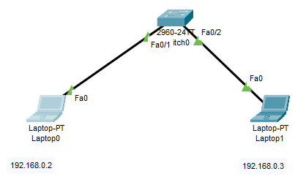

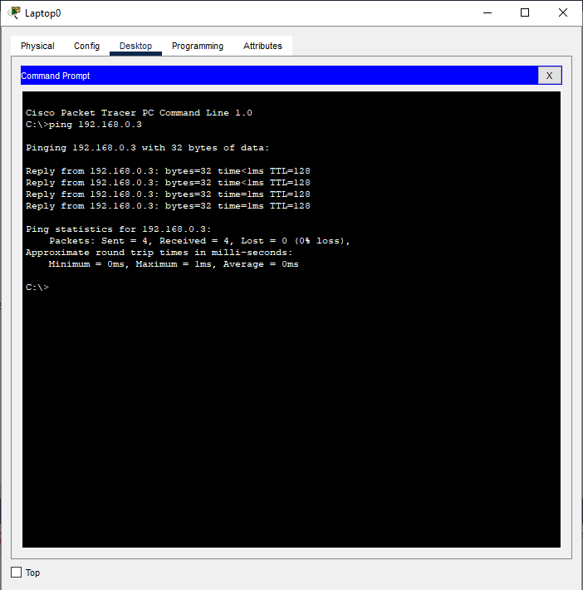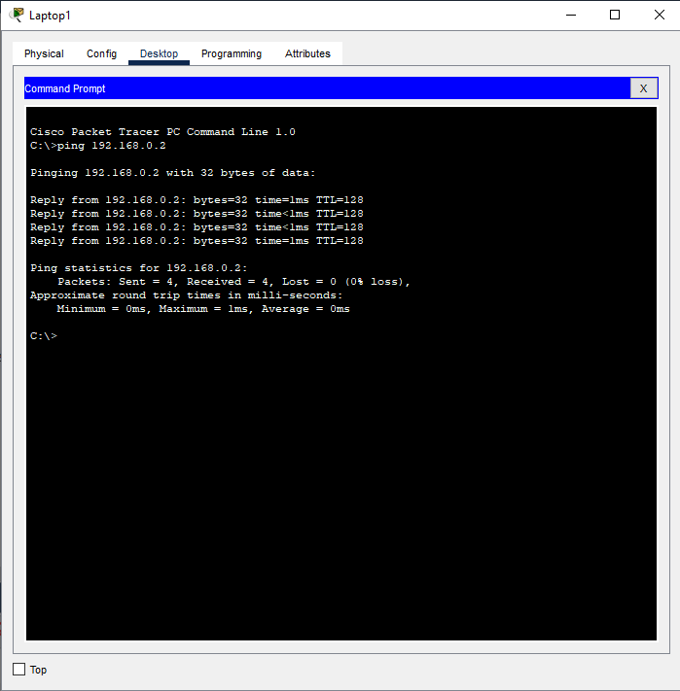

**Conclusion:**

In this lab, we successfully connected two PCs using a switch and verified their connectivity through the ping command. Unlike a hub, the switch efficiently forwards data only to the target device, reducing unnecessary network traffic. This lab demonstrated the fundamental operation of a switch at the Data Link Layer and reinforced the concept of MAC address-based forwarding. Switches are a vital component in modern networks due to their ability to manage traffic and reduce network congestion.

**Lab – 03**

**Title:** Static Routing Between Two PCs Using Two Routers in Cisco Packet Tracer

**Objective:**

To configure static routing between two PCs located in different networks, connected by two routers, and verify connectivity by pinging between the PCs using Cisco Packet Tracer’s GUI (without using CLI commands).

**Equipment:**

* Cisco Packet Tracer software
* 2 PCs (PC1 and PC2)
* 2 Routers
* 2 Switches
* 4 Straight-through Ethernet cables
* 1 Serial DCE cable (to connect the routers)

**Theory:**

Static routing is a process where the routes are manually configured on routers to define the path for data packets between different networks. In this setup, two separate networks are connected via two routers. The routers need static routes configured to allow communication between the devices in these networks. Each router will have knowledge of the local network it connects to and will forward packets destined for the remote network to the neighboring router. For example, if PC1 is in Network 1 (192.168.1.0/24) and PC2 is in Network 2 (192.168.2.0/24), each router will need to know how to reach the other network. We will use static routing to define these paths.

**Results:**

The static routes were successfully configured, and both PCs could ping each other across different networks through the two routers. This confirms that the static routing configuration is correct. - The ICMP packets from PC1 (192.168.1.2) to PC2 (192.168.2.2) and vice versa were successfully sent and received.

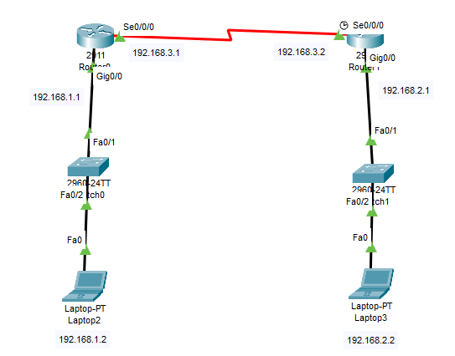

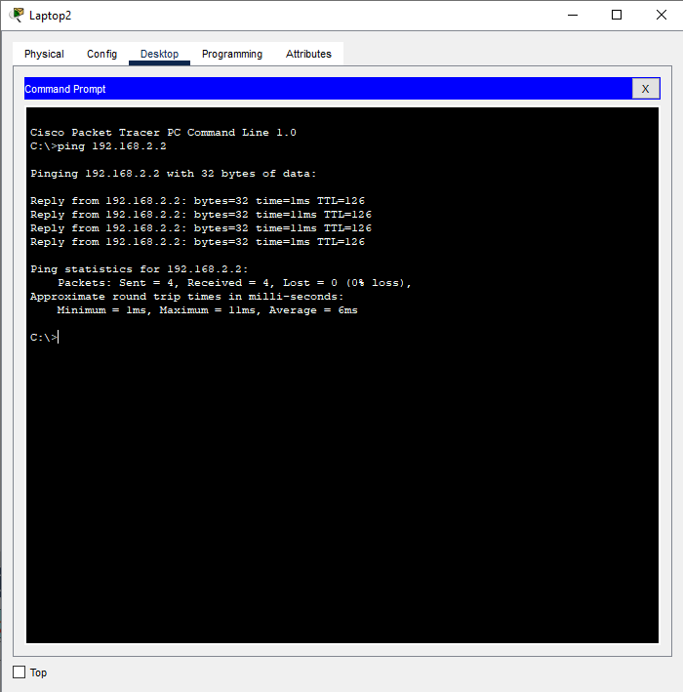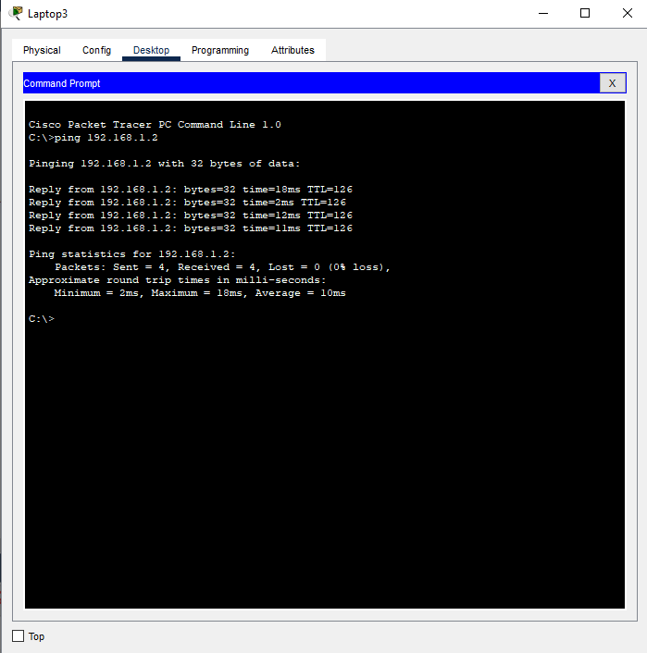

**Conclusion:**

In this lab, we established static routing between two different networks connected by two routers using Cisco Packet Tracer’s GUI. Static routes were manually configured on each router to allow communication between the networks. The ping results confirmed successful communication between the PCs. Static routing is an essential concept that allows routers to forward packets based on manually defined routes, particularly in smaller networks where dynamic routing is unnecessary.

**Lab – 04**

**Title:** Static Routing via Three Routers in Cisco Packet Tracer

**Objective:**

To configure static routing between two PCs located in different networks, connected through three routers, and verify the network connectivity by pinging between the two PCs in Cisco Packet Tracer.

**Equipment:**

* Cisco Packet Tracer software
* 2 PCs (PC1 and PC2)
* 3 Routers
* 2 Switches
* 4 Straight-through Ethernet cables
* 2 Serial DCE cables (to connect the routers)

**Theory:**

In static routing, network routes are manually added to each router, allowing them to forward packets between devices in different networks. In this scenario, we will set up three routers, with two PCs connected at either end of the network. Static routing will be configured on each router so that they know how to reach the remote networks via the intermediate routers. For example, PC1 in Network 1 (192.168.1.0/24) communicates with PC2 in Network 3 (192.168.3.0/24) by passing through Router1, Router2, and Router3. Static routes must be configured so that each router knows the correct path to forward data to the other networks

**Results:**

* After configuring static routing on all three routers, the ping command from PC1 (192.168.1.2) to PC2 (192.168.3.2) was successful.
* Similarly, the ping from PC2 to PC1 also succeeded, confirming proper communication between the two devices.
* The static routing configuration allowed each router to correctly forward data between networks based on manually added routes.

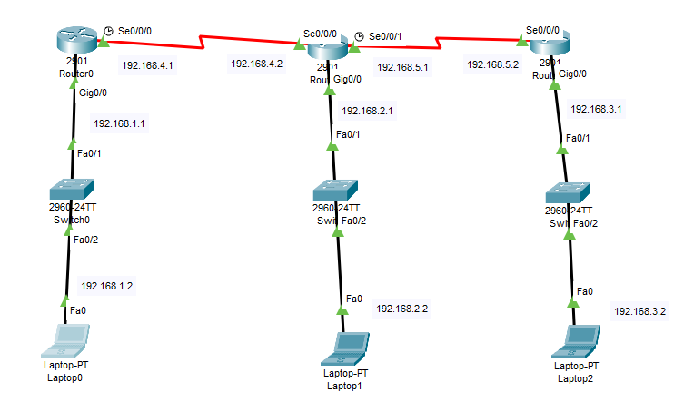

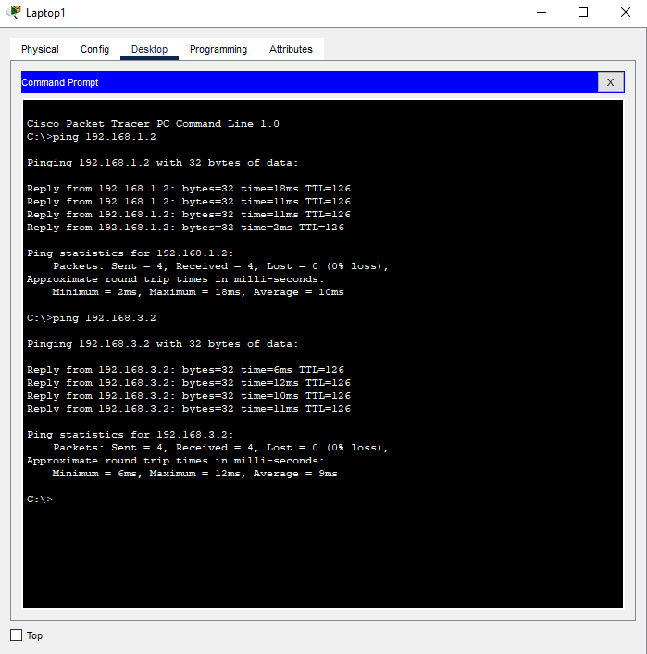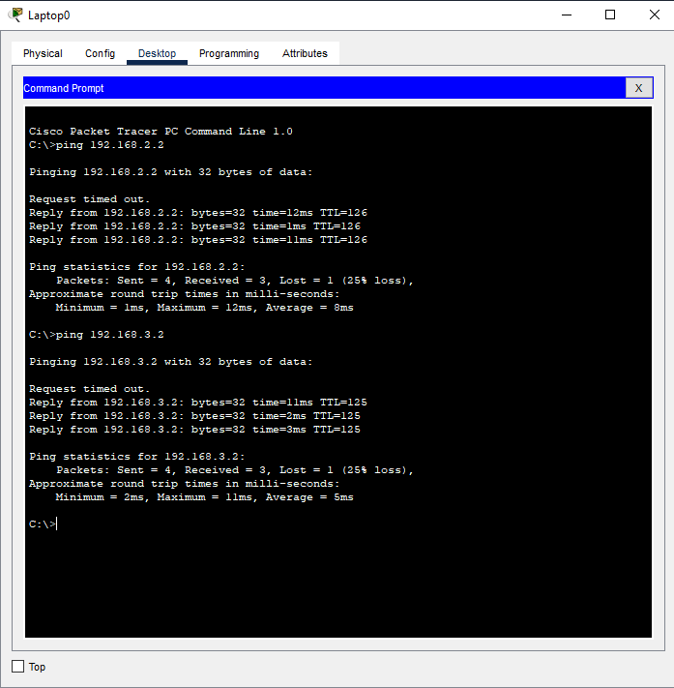

**Conclusion:**

In this lab, we successfully established communication between two PCs located in different networks via three routers using static routing. The static routes were configured using the GUI in Cisco Packet Tracer, ensuring each router knew the paths to the other networks. The successful ping tests between PC1 and PC2 verified that the routers were able to route the packets correctly through the configured paths. Static routing is an essential technique for managing traffic in small or controlled network environments.

**Lab – 05**

**Title:** Triangular Static Routing Between PCs in Cisco Packet Tracer

**Objective:**

To establish static routing between three PCs arranged in a triangular topology using three routers and verify connectivity by pinging between the PCs using Cisco Packet Tracer.

**Equipment:**

* Cisco Packet Tracer software
* 3 PCs (PC1, PC2, PC3)
* 3 Routers (Router1, Router2, Router3)
* 3 Switches (Switch1, Switch2, Switch3)
* 6 Straight-through Ethernet cables
* 3 Serial DCE cables (for router-to-router connections)

**Theory:**

In a triangular static routing topology, three routers are connected in a triangle, each having a separate network connected to a PC. Static routing is used to allow communication between the PCs across the different networks. Static routing involves manually adding routes to the routers’ routing tables, specifying the path to reach remote networks. Each router will need a static route for the two other networks, allowing them to forward packets correctly. In this setup, the PCs are located in three different networks: - PC1 (Network 1: 192.168.1.0/24) - PC2 (Network 2: 192.168.2.0/24) - PC3 (Network 3: 192.168.3.0/24) Each router will need two static routes to the other two networks.

**Results:**

* The ping between PC1, PC2, and PC3 was successful, confirming that the routers correctly routed packets using the static routes. 5
* Each router successfully forwarded packets to the correct networks based on the manually configured routes.

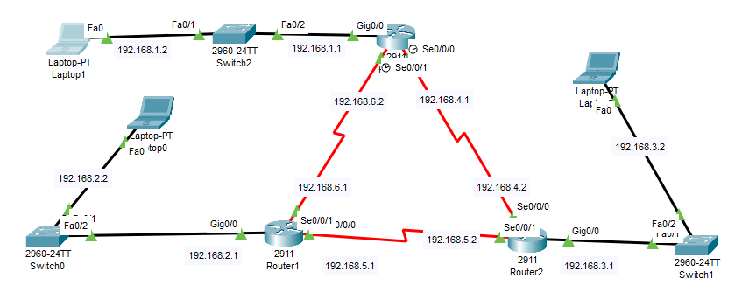

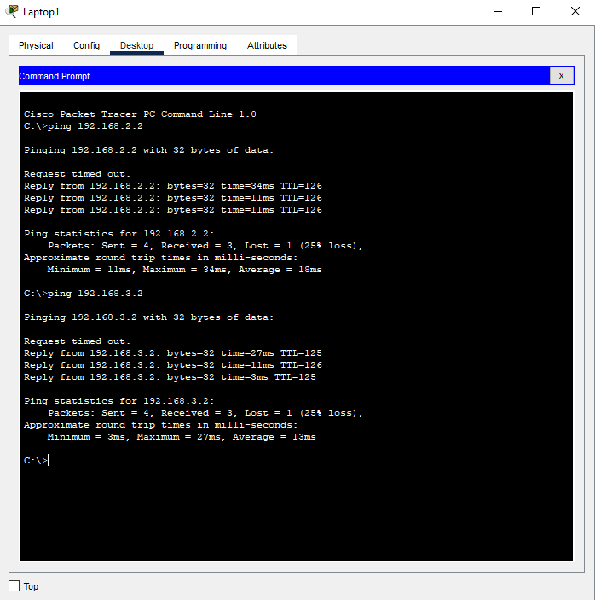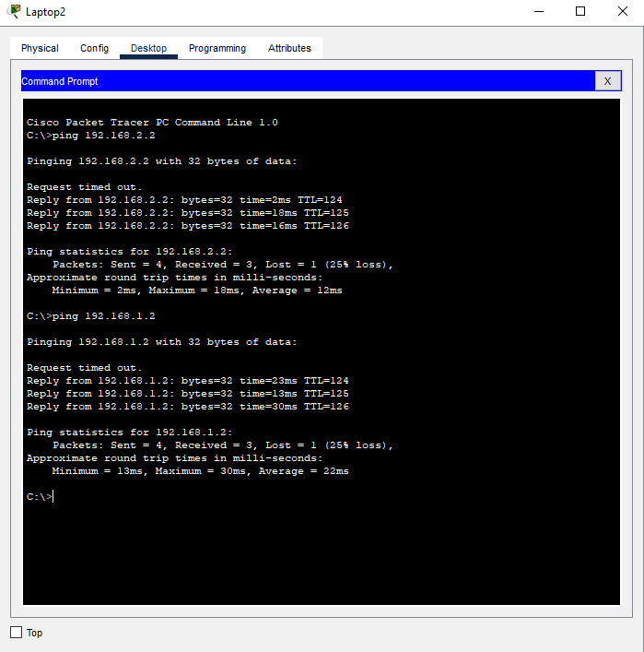

**Conclusion:**

In this lab, we configured static routing between three PCs connected through three routers in a triangular topology. Static routes were manually set up, allowing the routers to forward packets to the correct destination. The successful ping results between the PCs validated the proper routing configuration, demonstrating how static routing works in a triangular network setup.

**Lab – 06**

**Title:** Square Static Routing Between PCs in Cisco Packet

**Objective:**

To configure static routing between four PCs connected in a square topology using four routers and verify connectivity between the PCs using the ping command in Cisco Packet Tracer.

**Equipment:**

* Cisco Packet Tracer software
* 4 PCs (PC1, PC2, PC3, PC4)
* 4 Routers (Router1, Router2, Router3, Router4)
* 4 Switches (Switch1, Switch2, Switch3, Switch4)
* 8 Straight-through Ethernet cables (to connect PCs and Routers)
* 4 Serial DCE cables (for router-to-router connections)

**Theory:**

Static routing is a method where routes are manually configured on routers, allowing them to forward packets between different networks. In this square topology, four routers are connected to form a square, with one PC attached to each router. Static routes must be configured on each router to allow communication between the PCs, which are located in separate networks. Each router will be configured with static routes to forward packets to the other routers in the network. These static routes allow the routers to determine the best path for sending packets between the PCs.

**Results:**

* The ping between PC1, PC2, PC3, and PC4 was successful, confirming that the static routing configuration was correct and allowed communication between the PCs in different networks.
* The routers successfully routed packets between the networks using the manually configured static routes.

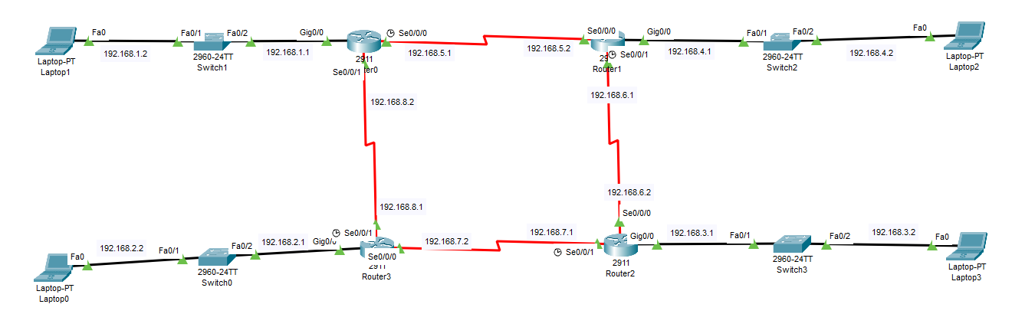

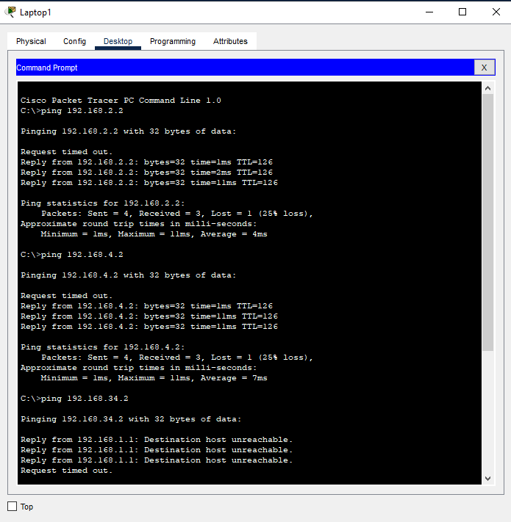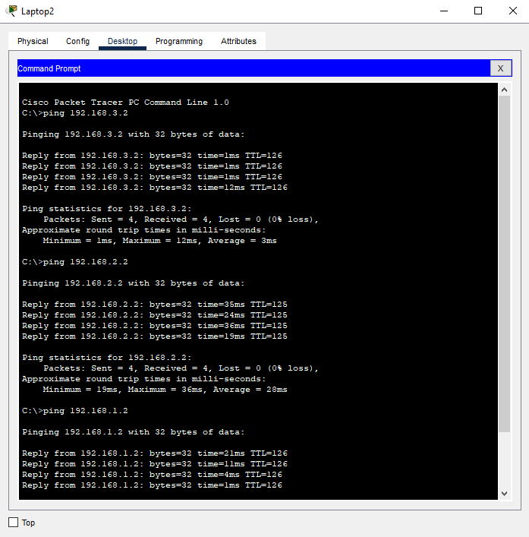

**Conclusion:**

In this lab, we successfully configured static routing in a square topology using Cisco Packet Tracer’s. By manually configuring the static routes on each router, the network allowed communication between four PCs located in different networks. This lab demonstrated the fundamental principles of static routing and showed how routers forward packets based on static routes to reach remote networks.

**Lab – 07**

**Title:** RIP Routing Configuration Between PCs in Cisco Packet Tracer.

**Objective:**

To configure RIP (Routing Information Protocol) routing between two PCs connected through two routers and verify connectivity.

**Equipment:**

* Cisco Packet Tracer Software
* 2 Routers (Router0, Router1)
* 2 Switches
* 2 PCs (PC0, PC1)
* Copper Straight-Through Ethernet Cables

**Theory**

RIP is a distance-vector routing protocol used to determine the best path for data packets through a network. It employs a hop count as a routing metric, allowing routers to share routing information and update their routing tables dynamically.

**Results:**

Successful pings between PC0 and PC1 indicate that the RIP routing configuration is functioning correctly, allowing data packets to traverse between different subnets.

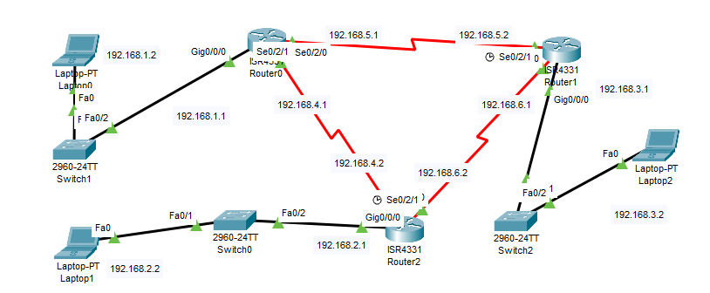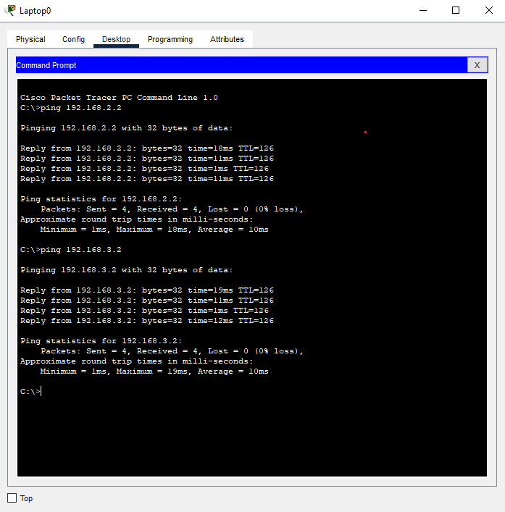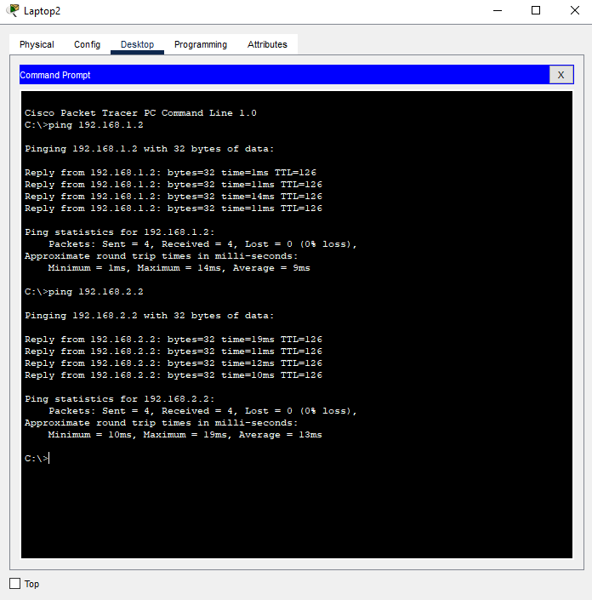

**Conclusion**

The lab effectively demonstrated the configuration of RIP routing between two PCs in Cisco Packet Tracer. The PCs successfully communicated across routers, validating the implementation of RIP for dynamic routing.

**Lab – 08**

**Title:** OSPF Routing Configuration Between PCs in Cisco Packet Tracer

**Objective:**

To configure OSPF (Open Shortest Path First) routing between two PCs connected through two routers and verify connectivity.

**Equipment:**

* Cisco Packet Tracer Software
* 2 Routers (Router0, Router1)
* 2 Switches
* 2 PCs (PC0, PC1)
* Copper Straight-Through Ethernet Cables

**Theory:**

OSPF is a link-state routing protocol that uses a more efficient algorithm to calculate the shortest path for routing packets within an IP network. It supports large and complex networks with rapid convergence and scalability

**Results:**

Successful pings between PC0 and PC1 indicate that the OSPF routing configuration is functioning correctly, allowing data packets to traverse between different subnets.

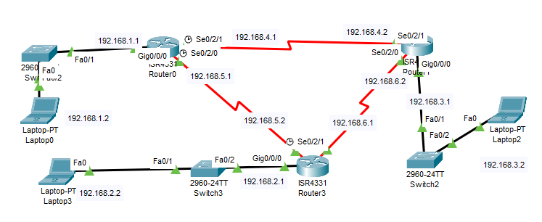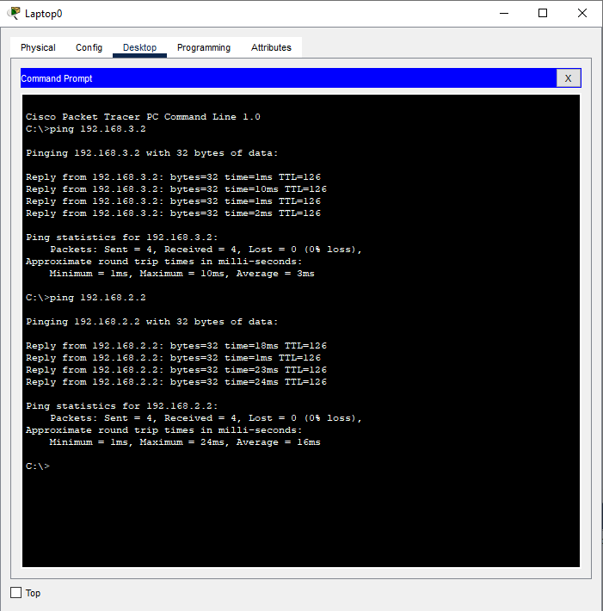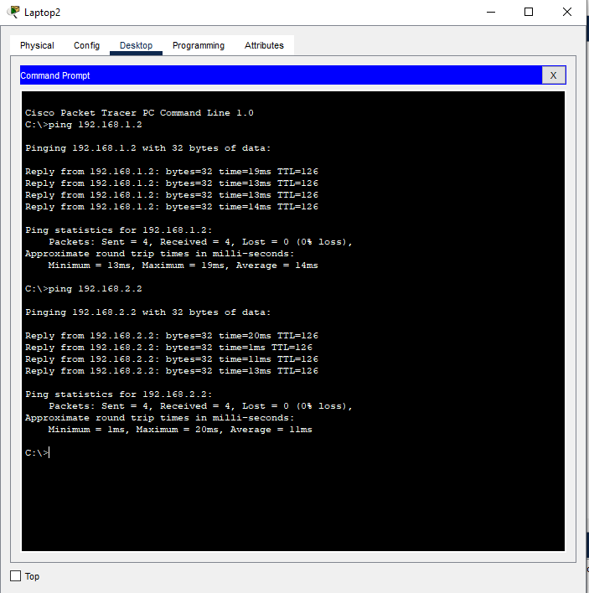

**Conclusion:**

The lab effectively demonstrated the configuration of OSPF routing between two PCs in Cisco Packet Tracer. The PCs successfully communicated across routers, validating the implementation of OSPF for dynamic routing.

**Lab – 09**

**Title:** VLAN Normal and Trunk Configuration Between PCs in Cisco Packet Tracer

**Objective:**

To configure normal VLANs and trunking between switches to enable communication between PCs across different VLANs.

**Equipment:**

* Cisco Packet Tracer Software
* 2 Switches (Switch0, Switch1)
* 2 PCs (PC0, PC1)
* Copper Straight-Through Ethernet Cables

**Theory:**

VLANs (Virtual LocalArea Networks) segment networks into different broadcast domains, improving security and performance. Trunking allows multiple VLANs to be carried over a single link between switches.

**Results:**

Successful communication between PC0 and PC1 indicates that VLANs and trunking are configured correctly, allowing traffic to flow between different VLANs.

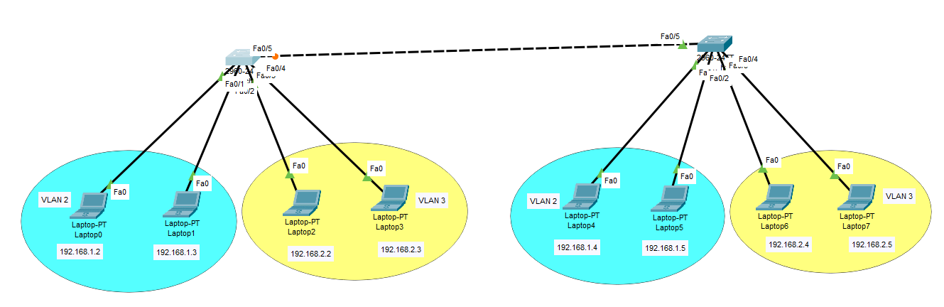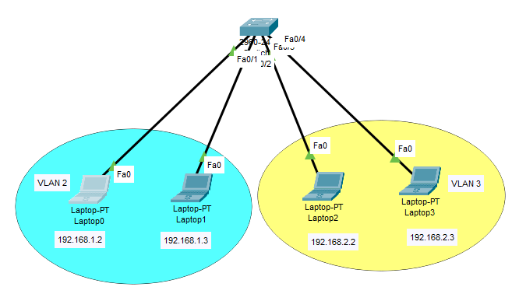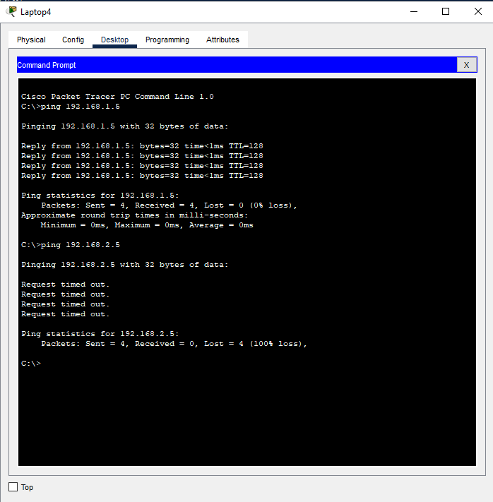

**Conclusion:**

This lab demonstrated the configuration of normal VLANs and trunking in Cisco Packet Tracer, successfully enabling communication between PCs in different VLANs.

**Lab – 10**

**Title:** FTP Server Configuration in Cisco Packet Tracer

**Objective:**

To configure and verify an FTP (File Transfer Protocol) server in Cisco Packet Tracer for file sharing between clients.

**Equipment:**

* Cisco Packet Tracer Software
* 1 FTP Server
* 2 PCs (PC0, PC1)
* 1 Switch • Copper Straight-Through Ethernet Cables

**Theory:**

FTP is a standard network protocol used to transfer files from one host to another over a TCP-based network. An FTP server allows users to upload and download files using FTP clients.

**Results:**

Successful connection and file transfer between PC1 and the FTP server indicate that the FTP server is configured correctly and operational.

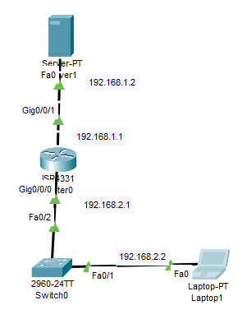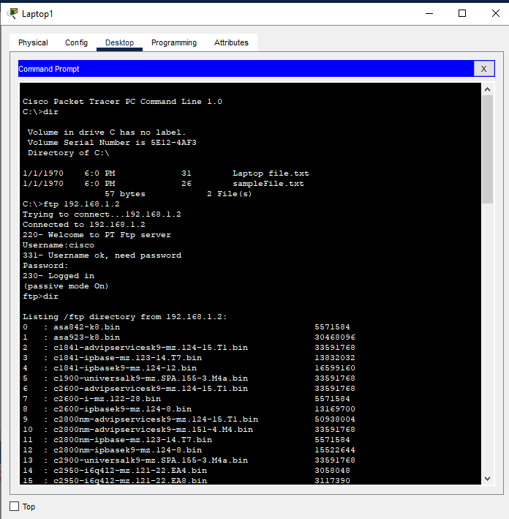

**Conclusion:**

This lab demonstrated the configuration and functionality of an FTP server in Cisco Packet Tracer, allowing for successful file transfers between clients.